The 12th Annual Wireless & Optical Communications Conference

Registration Form

April 25-26 (Friday-Saturday), 2003

The Wyndham Newark Airport Hotel, Elizabeth, NJ
Last Name First Name Middle Chinese

Address (No., Street, City, State, Zip Code, Country)

Affiliation Tel (Home) Tel (Work)

Email

Registration Fee (Two Days) | Regular | Sponsor Org. | Student | Self-Employed
Before April 18, 2003 | $140 | $120 | $40 | $70
After April 18, 2003 | $170 | $150 | $40 | $70
Days to Attend | Friday Saturday § one-day registration fee is a half of the two-day fee
Total Amount Enclosed | $

Additional Information
Payment:  - Only cash or check is accepted. Please make check payable to "CIE-USA" and mail to:  Wireless & Optical Communications Conference  126 East 56th Street 8 FL  New York, NY 10022  TEL: 212-752-2340  FAX: 212-826-3615  - Registration fee can be paid by mail or on site with the same discount rate as long as registration form is received by April 18, 2003. Lunch is included in the registration, but not guaranteed if the check is received after April 18, 2003. You may receive lunch allowance in lieu of lunch ticket.  - Meals for vegetarians are available by notifying the hotel official before the conference lunches. | Hotel Reservation:  - Discount room rate for either single or double beds room of $85 per night +6% tax is available for WOCC conference. Note the reservation deadline for the discount rate is on April 11, 2003.  - Please call 1-800-996-3426 or (908) 436-4600 for reservation at the Wyndham Newark Airport Hotel with group code "WOCC". The hotel has complimentary parking and shuttles to and from Newark Airport and the New Jersey Gardens Mall.  - For more information about the hotel, please visit http://www.wyndham.com/hotels/EWRNJ/main.wnt  - For more information about the conference, please visit our website: http://www.wocc.org
Driving Direction:

- From Newark Airport: Exit airport & follow US 1/9 north. Exit Haynes Ave, cross over 1/9 & turn left at U turn sign. Follow US 1/9 south. Bear right for Service Road. Hotel 1/4 mile past start of Service Road on right.
- From Rt. 78: Take exit 57 toward Newark Airport/North Area/South Area. Take the US-1 S/US-9 S ramp toward the airport. Keep right at the fork in the ramp. Take the US-9-Local S/US-1-Local S ramp. Take the ramp toward Service Road. Hotel 1/4 mile past start of Service Road on right.
- From NJ Turnpike: Take exit 13A toward Newark Airport. Merge onto NJ-81 N. NJ-81 N becomes US-1 & 9 N. Take McClennan Street ramp. U turn to go south on 1/9. Hotel is 1/3 mile on right.
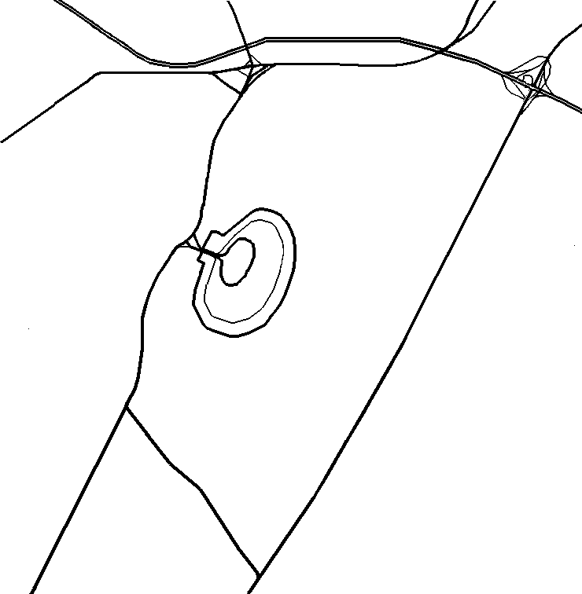
New Jersey Turnpike
Exit 13A
Exit 57
Marriott
Hotel
W
N
E
S

